**Name: Neeraj Parihar**

**Band: 30**

**Title: Engineer III** **2021 Self-rating (Trending):** *2/2*

**Time in Band** (Y/M)**: 1 y/2m**  **Time in Role** (Y/M)**:** 1y/2m

**The Four Performance Check-in Questions**

1. **What you did: As you think about your goals, what are you most proud of and what was the business impact?**

**In this year I have complete these task as part of my goals :**

* Getting good hold on python and implementing new functionalities to Alexa (January).
* Increasing the testcoverage(unit test) on Alexa (Feb).
* Log4j remediation (Mar- Apr).
* Secrets remediation (May - June).
* Learning java and reactive java, working on ABC to modularize the existing code(June).
* Worked with Aquila team to update Acesapi endpoint url to complete the aquila scan(July).
* Worked on HMAC token application and code implementation and it’s successful validation at Apigee and CBIS end to authenticate the user request from CAPTR and send proper response back to channel.
* Worked on implementing the Decommission Message in the CAPTR that was being shown to the user trying to make registration on the alexa after the decommission date.
* As a part of inclusive language worked on creating the document for the gathering the occurences of specified words in the Aces-web code repository.
* Participated in GrowthHack and worked on an idea of creating an master bot which computes the performance of other bots and identifies the pain points or the areas of improvement in which the bot is not performing well.

I am most proud of working and completing the Log4j remediation and secrets remediation. For partnership team, I was working on the log4j remediation along with the apigee team folks. The business impact of secrets remediation is that Users need to use authentication methods to access sensitive information or company resources. Whenever these secrets or credentials are transmitted across the company, there is a risk of data leakage or lost passwords. For Log4j remediation, we had to update the previous version of log4j whose impact was seen industry wide. I am also proud of researching on the HMAC token task and understanding its working and why it is important from the security perspective and then implementing the code for the same.

1. **How you did it: How did you Set the Agenda, Bring Others With You and Do It the Right Way using the new leadership behaviors?**

* In order to achieve the above mentioned goals, I took the task assigned very seriously and always approached them with learning mind-set.
* I started by discussing the task with my team and did the requirement gathering. Then divided the task on the weekly basis which was further divided on the daily basis. I always tried to complete what I have for the day.
* I worked with members from other teams as well who have an idea about the technology that I am working. By keeping their important time in mind always tried to keep the meeting on the point and always tried to get my doubts cleared.
* Before moving ahead with my approach, I always disscused it with the members of the team to get their thoughts on it.
* For anyone who needed my assistance with anything, I have always helped them either by doing a 1:1 meetings or on the slack.
* Always presented my thoughts and doubts in front of team that were their in my courious mind.
* I have worked with full commitment and tried to work on completing the task for a particular sprint irrespective of teams attendance.

1. **What you learned along the way: What didn't go so well? What have been your biggest learnings and what will you do differently or develop further as a result?**

**Learnings ::**

* During growthhack, I learnt about how to work with new member as a team, how does the leadership works towards bringing everyone together and working and completing the task within such a short duration.
* While working on HMAC token, it helped me to understand the dependencies of the teams on each other how the validation that is being performed at one point is being taken into consideration at the other end.
* Workings and Importance of Api proxy.Deployment of proxy on apigee hub and dtc.
* Deploying a branch and checking the the pods and logs on ecp developer console and splunk.
* Implementing class & functions and writing unit test in JAVA and python.
* How to interact with vault (UI & postman) and perform the update and fetching of data from vault.
* How to support a team-mate, interact with team and put forward your thoughts and ideas.
* How to complete the task on time and work in direction of supporting and amex in providing better user experience.

**Didn’t go so well :**

* For some of the task like HMAC validation and Alexa decommission, I had invested my time on them and completed them from my end but these didn’t go into production because of the time constraint and no more use of the functionality as the service is going to be decommission soon. I would be much happy if it would have gone into production.
* Nothing more to point out in it, as everything went smoothly. Didn’t get to work much on development and coding skills, so looking forward to work on that and help the team with development and coding aspects.

**Biggest Learning :**

* Always think of the bigger picture considering Amex, how you are achieving the better customer experience by completing a task. Always respect the thoughts of every member of the team and work along with them in the personal as well as professional growth.

1. **Other highlights: Is there anything else you would like to highlight?**

* Participating in 2022 Early Careers Program Global Graduate Coding Challenge and winning it.
* Participating in the GrowthHack and working with the amazing minds and learning many things from them was one of the highlights for me this year.
* Completed my 5+ learning and learned node.js as part of it.
* I would like to highlight that every member on team has always helped me in completing my task and have also helped in my personal growth. I am very honored and pround of working with such a team. I would like to give my special thanks to Ilam and Nitin who have helped me with log4j remediation.

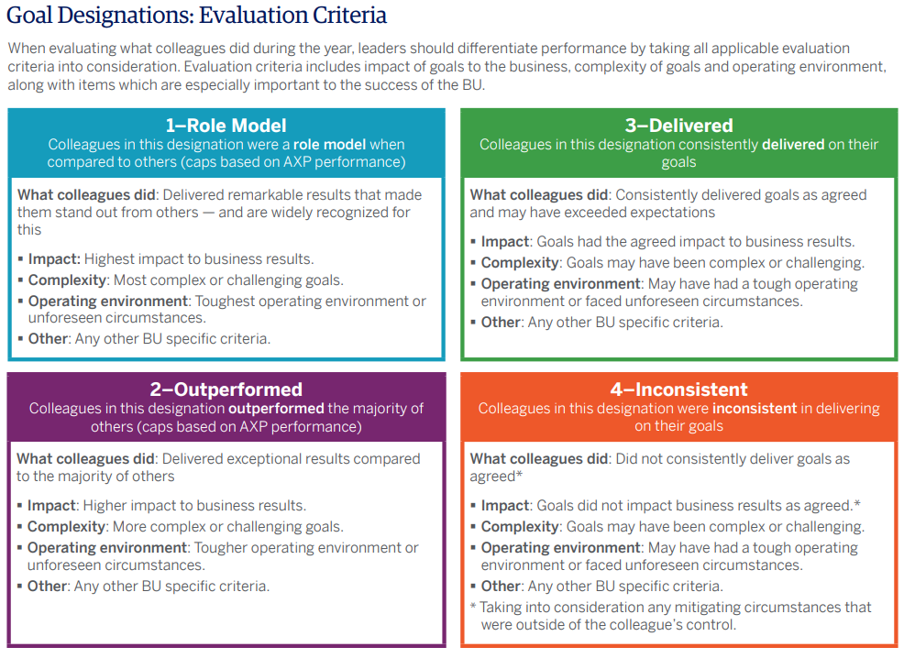

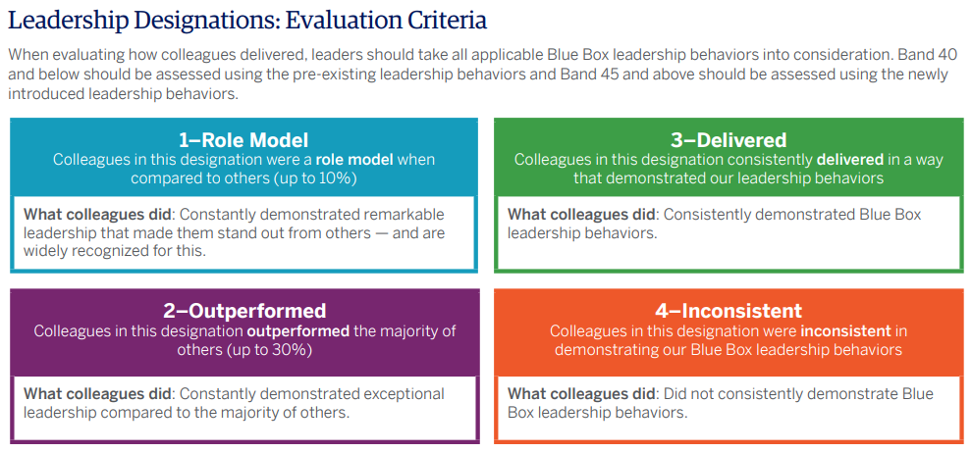

**Leadership Behaviors for Individual Contributors**

**SET THE AGENDA**

**Define What Winning Looks Like**

I work with my leader to create a clear and compelling definition of what winning looks like for my role, making sure the focus is understood and why it matters. I understand that a clear definition of what winning looks like is essential to the organization’s culture, and to winning the hearts and minds of my colleagues.

**Put Enterprise Thinking**

First I intentionally connect my agenda to enterprise priorities, ensuring there are direct and clear linkages to how it supports our Framework for Winning. Specifically, I make sure my approach balances the needs of customers, partners, colleagues, and shareholders

**Lead with an External Perspective**

I understand that external influences on our customers are creating rapid change in our industry. I take steps to make sure I learn about and look for opportunities to incorporate external thinking into my work, resisting the temptation to be insular and internally focused.

** BRING OTHERS WITH YOU**

**Build the Best Team**

I realize there is no substitute for being a part of a team that is mission capable, focused, and motivated to win. The broader, stronger and more diverse the team, the better our results. I am an active and engaged team player with a responsibility to contribute my best effort and unique perspective for the overall success and performance of the team.

**Seek and Provide Coaching and Feedback**

I am willing to provide candid coaching and actionable feedback to my leader and my colleagues. I am also committed to learn how I can be more effective by listening for, and acting on constructive feedback.

**Make Collaboration Essential**

I understand that collaboration is not the same as consensus. I role model the importance of valuing the input of others, while maintaining clarity on ownership of decision rights. Once a decision is made, my role is to join with the team to help support and execute the decision.

**DO IT THE RIGHT WAY**

**Communicate Frequently, Candidly, and Clearly**

I take proactive steps to communicate clearly and confidently with my partners, leaders, peers and team, ensuring they are appropriately involved. I aim to inspire through my actions and do so with a high degree of active listening, transparency, and candor.

**Make Decisions Quickly and Effectively**

I strive to make quick decisions, by utilizing the tools to plan, decide and execute to achieve goals. I make sure to balance all relevant perspectives without being constrained by consensus. Although speed is important, I understand that it must be balanced with the quality of our products and services.

**Live the Blue Box Values**

Our Blue Box Values are enduring and serve us well. They are important components of a culture that has made us a successful company for more than 160 years. I embrace these values, and I represent the very best that American Express stands for .

**Demonstrate the Courage Great Leadership Demands**

I accept the responsibility to speak up and challenge when I believe my point of view, or my team’s point of view, needs to be more completely considered by those making important and relevant decisions. I have the courage to challenge the status quo.